You can get more configuration info about slave via page <https://wiki.jenkins-ci.org/display/JENKINS/Step+by+step+guide+to+set+up+master+and+slave+machines>

1. Now you need to connect your slave machine to the master using the following steps.
   1. On you slave machine go to the **Jenkins server** url.
   2. Go to **Manage Jenkins** > **Manage Nodes**, Click on the newly created slave machine.
   3. Click on the **Launch** button to launch agent from browser on slave.  
      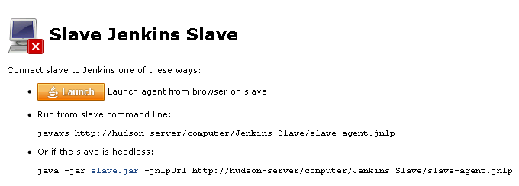
   4. Run the program.  
      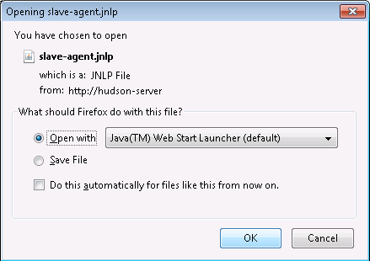
   5. Now you should see the Slave machine connected under **Nodes**.
2. If you want the service to run on start-up of the slave machine do the following (Windows only directions):
   1. In the Slave agent program running on your slave machine, click **File** --> **Install as Windows Service.**  
      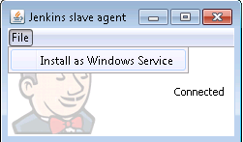
   2. **Start**, type Services/services.msc and Select the **Services** program.
   3. Find **Jenkins/Hudson Slave** in the list, Double click to open.
   4. Select **Startup type** --> **Automatic**.
   5. Go to the **Log On** tab, change the **Log on as** to a user of your choice (Special user account Jenkins recommended).
   6. Make sure that auto login is set for the slave machine for the user account, then the VM (or physical computer) should connect and be available when needed.

Also: take a look at ﻿﻿[Distributed builds](https://wiki.jenkins-ci.org/display/JENKINS/Distributed+builds)